Customer profile verification form
Assignment date | Agency name | Contact number | Report submission date
29/06/2026 | Virtual OO7 Investigation Pvt. Ltd. | 9161022060 | 24/07/2026
Decision | LA met | Evidence available | No
Evidence details | LA residence Photo
Remarks | Meeting done with LA.

Application no. | Policy no | Issue date | Product | Sum assured | Premium amount
NA | K9588053 | 25/04/2026 | NA | NA | 8333/- monthly
Case details
Name of Proposer (PR) | GEETA AHIRWAR
Name of Life Assured (LA) | GEETA AHIRWAR
Communication address | Shivsankar muhalla Chaubara Nowgong  Nowgaon Pin code: 471201
Permanent address | Shivsankar muhalla Chaubara Nowgong  Nowgaon Pin code: 471201
Contact number | 7827114949
Proposal verification
Locality of LA | Urban
Existence of LA established | Yes
Was LA met | Yes
If LA not met, whom did you meet | NA
If family then relationship with LA | NA
Life Assured details
Date of birth of LA | 01-01-1989
Identity proof of LA | Attached
Address proof of LA | Attached
Education of LA | Not shared
Health details of LA | Healthy
Habits of LA | NA
Quantity/ no. of years | NA
Physical appearance of LA | Fit and fine
If Handicapped, then | No
Existing insurance of LA | YES
Live Photo of LA | YES
Photo of residence of LA (complete house of LA should be visible) | NA
Proposer details
(LA details to be collected where LA and Proposer is same)
Occupation | Salaried
Name of Company | Private job
Income | 03 lakh/- annual income
Income proof | No
Number of members in family | 02
Number of earning members in family | 01
Photo of office/shop | Attached
Type of house | Owned
Vicinity check
Personal details as per vicinity
Education of LA |  |  | Graduation
Health details of LA |  |  | Healthy
Habits of LA |  |  | Not Confirm
Quantity/ no. of years |  |  | NA
Physical appearance of LA |  |  | Fit and fine
Since how many years is LA’s family staying at this address |  |  | Not Confirm
Income details as per vicinity
Occupation |  |  | Salaried
Name of Company |  |  | Private job
Income |  |  | 03 lacs annually approx.
Family income |  |  | NA
Number of members in family |  |  | 02
Number of earning members in family |  |  | 01
Sr no | Name of person/company | Relationship |  | Contact no | Address
1. | Shivam | Nearby People |  | Not shared | Nowgaon
2. | Mithilesh | Nearby People |  | Not shared | Nowgaon
Remarks/ Details: The above mention told that LA lives on the given address with his family and looking wise he is fit and healthy.
Vicinity check conclusion: Positive
Sr no | Name of Hospital/ Doctor/Chemist | Contact no |  | Address
1. | Pooja Medcial | NA |  | Kanpur Nagar
2. | Shir Medicare | NA |  | Kanpur Nagar
Remarks/ Details: No Findings

Medical check conclusion: No negativity found from these places.
In case of DBRCD, Death Certificate / Cemetery Verification:
Name of authority
Designation and location
Contact number
Date of death in register
Death certificate issue date
Cause of death (if available)
Life Assured cremation/burial |  | Timing:
Death certificate verified | Genuine / Bogus
Other insurance details
(Please collect husband’s insurance details if Life Assured is a housewife, parent’s insurance details if Life Assured is a student)

Name of Life Assured/ Proposer | Name of Company | Contract/ Proposal number | Sum assured | RCD | Policy status (Inforce/ Lapsed/Applied)
Not shared | Not shared | Not shared | Not shared | Not shared | Not shared
Family History

Sr. No. | Name of member | Relationship with Life Assured | Age | Occupation | Income | KYC
1. | Geeta Ahirwar | LA | 37 | Salaried | 03 lakhs/- | Attached
2. | Subham | Son | NA | NA | NA | NA
3. | NA | NA | NA | NA | NA | NA
4. | NA | NA | NA | NA | NA | NA
5. | NA | NA | NA | NA | NA | NA
Overall Remarks/Conclusion
Discreet check
IO visited the mentioned address and met with nearby residents Mr. Naman and Mr. Kushal.
IO inquired about the mentioned address and the LA.
They informed that the mentioned address belongs to LA and that they know him.
Nearby people also stated that the LA is doing a job in Prayagraj.
Overall Remarks
IO visited at the mentioned address and met with LAs mother.
IO asked about LA she stated that LA is posted in Prayagraj.
IO make a call to LA on provided contact number and the call was picked by LA.
IO told that he is in investigating officer on behalf of ICICI Prudential life insurance and asked for policy verification.
LA shared the requested information over call.
LA shared that his educational qualification is graduation.
LA is married and he is doing a job in U.P.P PRAYAGRAJ as an accountant through which he earns an annual income of approximately 06 lakhs.
LAs family consists of 05 members with one active 01 earning members.
LA shared that his mother Mrs. Geeta Gupta is the nominee under the policy.
LA has shared his Pan card which is attached with this report.
LA shared that the he is not sure about policy premium and the term.
When asked about his health condition the LA stated that he does not have any health or medical issues and does not have any kind of addiction.
During the call the LA requested verification in Prayagraj but did not share the address He stated that the IO should call him after reaching Prayagraj and he would then share the address.
Prayagraj IO called the LA multiple times LA has scheduled multiple appointments but did not meet the IO.

Second Visit
After sometime, IO got a call of LA and he scheduled the appointment with LA.
IO visited at LAs Prayagraj address and met with LA.
IO told that he is in investigating officer on behalf of ICICI Prudential life insurance and asked for policy verification.
IO confirmed all the details with LA which was earlier shared by LA over call.
LA shared that the policy premium is approx. 35000 yearly.
LA has shared his Job ID card which is attached with this report.
When asked about his health condition the LA stated that he does not have any health or medical issues and does not have any kind of addiction.
All Photographs with Geo tagging
First Visit:
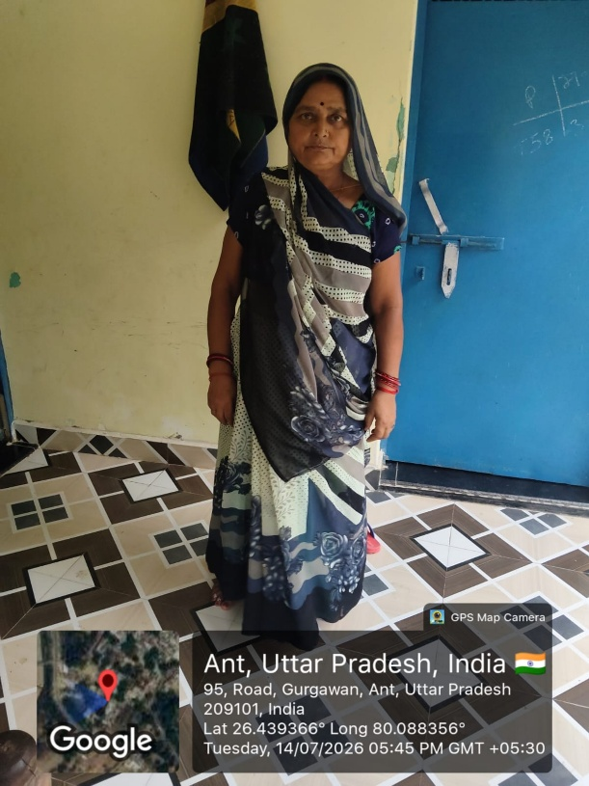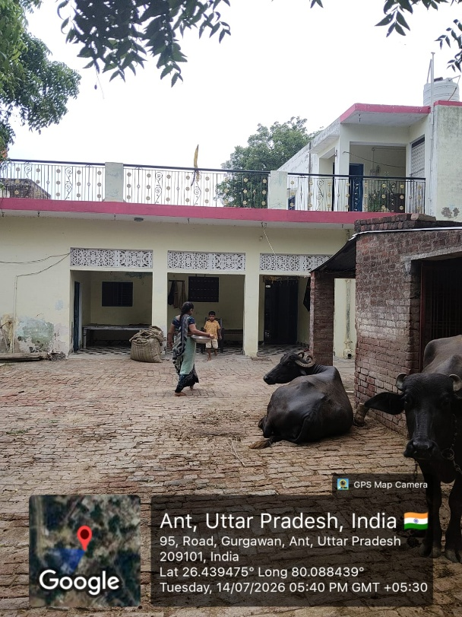
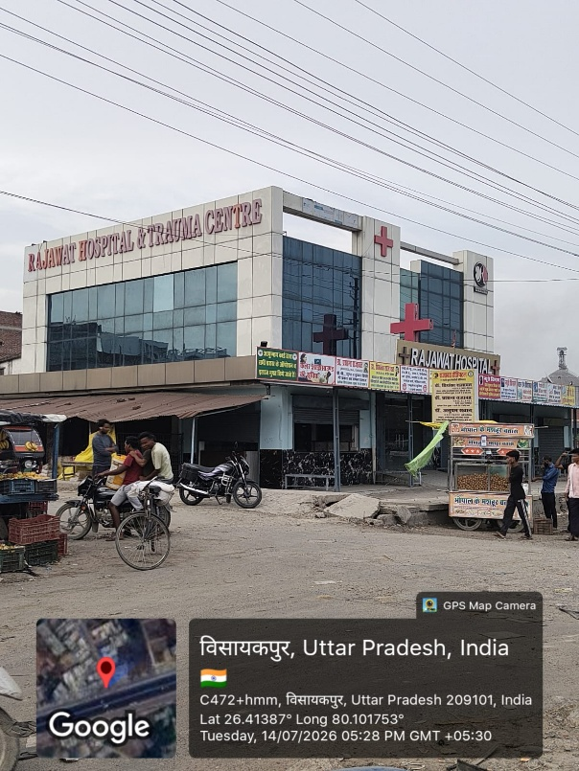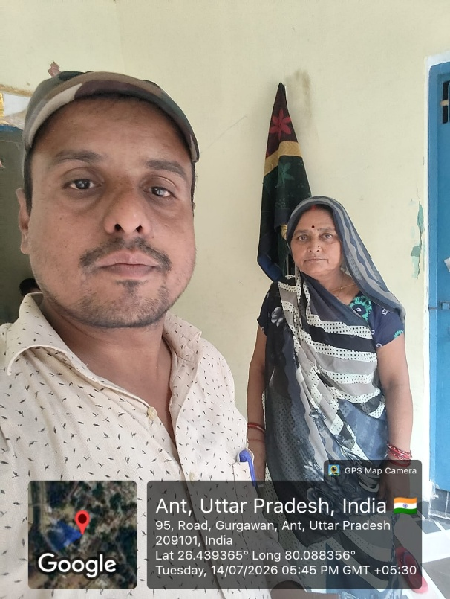
Second Visit:
